
Mental Health and Well-being Advocacy Resource: Template

Name of the initiative  Give a brief descriptive name for the activity or initiative you were involved in organising related to mental health and well-being | Breakfast Club
Target group  Was it aimed at all students or staff or a particular group? | Students, during pre-exam period.
Description  Give a short description of what was involved in organizing the activity or initiative. | A free breakfast club held 8 – 9 am on two weekday mornings. Run by two library services advisers. Providing: cereals, pastries, tea, coffee, fruit and fruit juices.
Partners  Was this solely run by the library or were other stakeholders involved, and if so how? Were students involved in planning the session, if so, how? | Library in conjunction with student union shop and associated staff.
Strategy  How, if at all, was the activity linked into wider library or institutional strategy? | Funded by University Planning and Resources Group (Cost of Living group bid), the initiative aligns with the library vision ‘Connected connector’ theme: Developed a programme of events, exhibitions and activities that encouraged people to connect and support wellbeing
Evaluation  How, if at all, was the activity evaluated? | Direct verbal and self-written feedback from users.
What worked  Colleagues are looking for tips to help them run their events more effectively, what tips would you share to someone wanting to repeat what you have done?  If applicable, please include how many people attended (if an event) or engaged (e.g. website clicks) or another appropriate measure for your initiative. Did this match expected engagement? | The event attendance grew from under 20 to regularly over 100 per morning throughout the Lent term.  Excellent rapport between staff and students  Students formed friendships  Wider library and campus activities were promoted via e-screens and flyers etc
What did not work  What you would change if you were doing it again? Sharing what did not work can be as useful to help others as what did work. | Limit items to prevent stock running low.  Order fewer perishable items.  Consider fruit/drinks only to be more cost effective.
Photo  Are there any photos you can share that give us a feel for the initiative? | 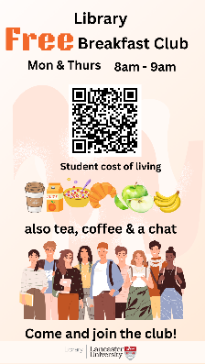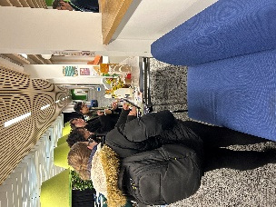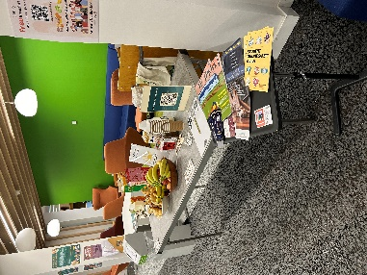
Resources
Is there a URL related to the initiative?
Your name, institution and contact details: Claire Woods, Lancaster University Library. c.woods4@lancaster.ac.uk
Are you willing to share your contact details to other ALN staff so if they want to find out more they can contact you directly? Yes

