
Mental Health and Well-being Advocacy Resource: Template

Name of the initiative  Give a brief descriptive name for the activity or initiative you were involved in organising related to mental health and well-being | Library Hiking or ‘Liking’ (sorry)
Target group  Was it aimed at all students or staff or a particular group? | Library Staff
Description  Give a short description of what was involved in organizing the activity or initiative. | Checking train times and prices, organizing a route. Promoting via the library wellbeing teams channel and separate hiking email list.
Partners  Was this solely run by the library or were other stakeholders involved, and if so how? Were students involved in planning the session, if so, how? | Library staff only
Strategy  How, if at all, was the activity linked into wider library or institutional strategy? | General wellbeing, encouraging movement and social interaction.
Evaluation  How, if at all, was the activity evaluated? | Word of mouth feedback, positive comments.
What worked  Colleagues are looking for tips to help them run their events more effectively, what tips would you share to someone wanting to repeat what you have done?  If applicable, please include how many people attended (if an event) or engaged (e.g. website clicks) or another appropriate measure for your initiative. Did this match expected engagement? | Some people chose to drive or were close enough to walk to the start but always find an easy public transport option, single bus, single train etc. These events started pre-Covid, shut down for a few years with train strikes not helping either, Restarted in October 2024, usually one every alternative month. Numbers vary depending on walk start location but 5-6 for some and 14 on the latest one to Wigan, lured by the promise of pies and beer….
What did not work  What you would change if you were doing it again? Sharing what did not work can be as useful to help others as what did work. | So far, so good.  Challenge now is to keep it going and get others involved in setting the routes and leading the walks.
Photo  Are there any photos you can share that give us a feel for the initiative? | Group distracted by a dog stealing a sausage roll from under a pram.  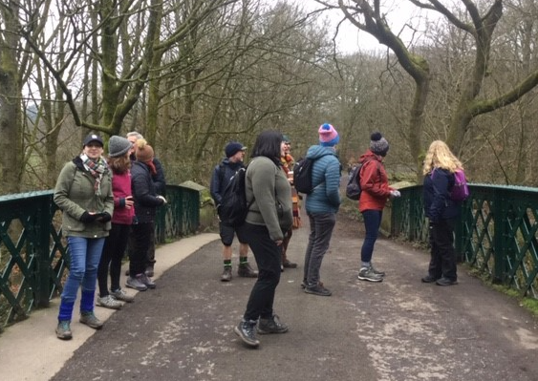
Resources
Is there a URL related to the initiative?
Your name, institution and contact details: Mark Hastings, University of Manchester Library, mark.hastings@manchester.ac.uk
Are you willing to share your contact details to other ALN staff so if they want to find out more they can contact you directly? Yep.

