
Mental Health and Well-being Advocacy Resource: Template

Name of the initiative  Give a brief descriptive name for the activity or initiative you were involved in organising related to mental health and well-being | Be well@NCL: a collection of tried and tested books focusing on mental health.
Target group  Was it aimed at all students or staff or a particular group? | Available to all students, but by default also open to University staff as well.
Description  Give a short description of what was involved in organizing the activity or initiative. | Be well@NCL is a discreet collection of books which are replicated in three of our campus libraries. Students / staff can either pick a book off the shelves or be directed to particular book in a therapy session. The collection sits on the University wellbeing app and includes information which can be used within a therapy session or can be accessed individually by students themselves.  The setup of the collection involved liaising with therapists in the student wellbeing team, the purchasing of the stock, the creating of a brand and marketing materials and deciding on a location of the collection within our libraries.  Ongoing tasks include the development of the collection (in terms of titles and scope) and the ongoing marketing of it.
Partners  Was this solely run by the library or were other stakeholders involved, and if so how? Were students involved in planning the session, if so, how? | This collection was developed in conjunction with therapists in our Student Wellbeing team and based on the national Reading well scheme. Therapists chose the additional titles based on their professional experience and the knowledge of the student need and population here at Newcastle.
Strategy  How, if at all, was the activity linked into wider library or institutional strategy? | The collection fits into the University’s overall Health and Wellbeing Strategy. This policy document stresses not only the need for initiatives to lead to wellbeing action and changing of behaviours, but also has an emphasis of the importance of consulting and collaborating with wellbeing experts.  The Be well@NCL collection has been founded on collaboration and will continue to do so. It is also acts as a low-level point of action for both staff and students to improve their own mental health and wellbeing.
Evaluation  How, if at all, was the activity evaluated? | The collection is evaluated by the collection of loans and online access statistics (where appropriate) every quarter. We also have anonymous evaluation postcards which sit alongside the book. Students can fill these in and place them in anonymous boxes beside the collection. Anecdotal feedback is given via the therapists and we are in the process of developing a methodical system where the therapists can record the number of referrals and any qualitative comments they receive.
What worked  Colleagues are looking for tips to help them run their events more effectively, what tips would you share to someone wanting to repeat what you have done?  If applicable, please include how many people attended (if an event) or engaged (e.g. website clicks) or another appropriate measure for your initiative. Did this match expected engagement? | Collaboration and buy in from senior staff members from the Student Health and wellbeing team (and senior library team) have been crucial in the success of this project. We initially ran it as demonstrable pilot project and this also helped staff and partners see the merit of it and allowed us a team the space to try new ideas. Ongoing dialogue and meetings with wellbeing colleagues has also meant that adaptation and updating of the collection has been possible along the way.  Having a strong identifiable brand has been extremely useful as we have promoted the collection across campus. The inclusion of our collection information on the University wide app has also been key. This has enabled students to see and access our Be well@NCL collection alongside all the other initiatives and services available to them. Creating an interactive reading list and a strong web presence also helped to make the collection accessible and easily marketable. In addition, quotes from the books themselves have also served as a good way to promote the collection over social media and plasma screens. Tying in these promotions with key strategic university or national wellbeing days / weeks / months has also been strategy which has paid dividends.
What did not work  What you would change if you were doing it again? Sharing what did not work can be as useful to help others as what did work. | If we ran this initiative again, we would create (from the start) a brief collection policy document outlining the scope of the collection, it’s purpose and its maintenance going forward. This would make it clear to all parties involved (and to other potential partners) what the remit of the collection was.  We would also give ourselves more lead in time from concept development to implementation. The original pilot was delivered in less than 6 weeks. We advise at least 3-6 months lead in time in order to allow more time to establish collection scope and partnership working.
Photo  Are there any photos you can share that give us a feel for the initiative? | 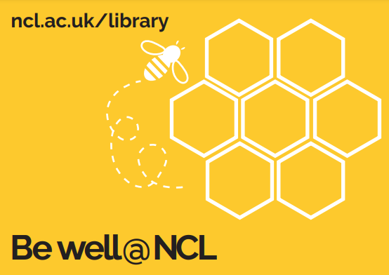  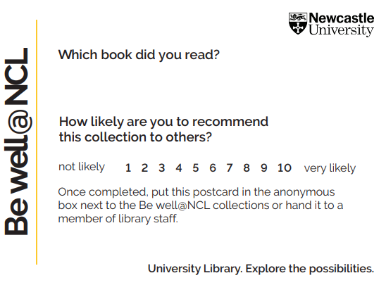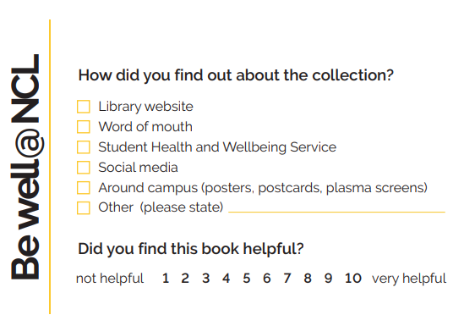  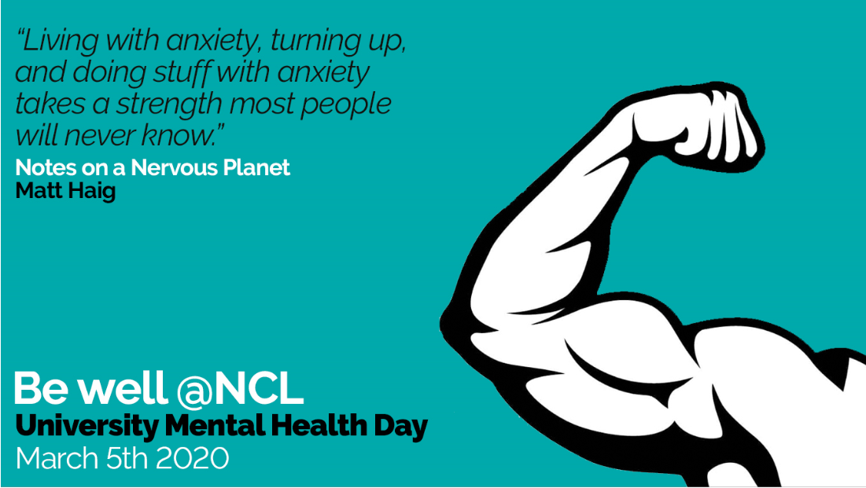  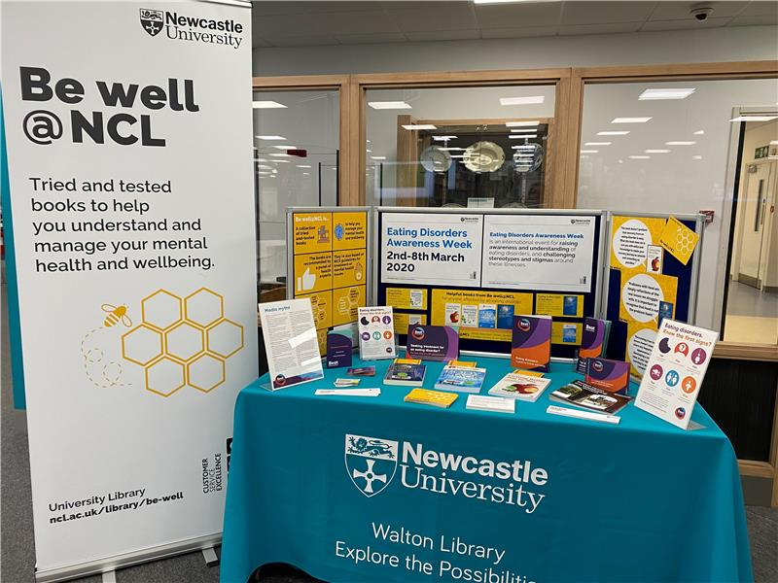
Resources  Is there a URL related to the initiative? | https://www.ncl.ac.uk/library/resources-and-study-support/be-wellncl/
Your name, institution and contact details. Anne Archer, Newcastle University, anne.archer@ncl.ac.uk
Are you willing to share your contact details to other ALN staff so if they want to find out more they can contact you directly? Yes

