
Mental Health and Well-being Advocacy Resource: Template

Name of the initiative  Give a brief descriptive name for the activity or initiative you were involved in organising related to mental health and well-being | Calm Space
Target group  Was it aimed at all students or staff or a particular group? | All students – particularly those seeking a different kind of library space to relax / reflect / recharge. It was set up in Oct 2021 to also address the needs of students anxious about a return to the physical campus and being around lots of people, promote campus wellbeing services and house a Reading for Pleasure collection of fiction books.
Description  Give a short description of what was involved in organizing the activity or initiative. | We set up a small cross-library task and finish group to manage the project and asked for volunteers to join the group, so we had a group really interested and invested in the project rather than seeking a representative from every library team.
Partners  Was this solely run by the library or were other stakeholders involved, and if so how? Were students involved in planning the session, if so, how? | We consulted with:  - Counselling, Student Success and Mental Health colleagues  - Put out feelers through LIS-Link to learn from the sector about similar initiatives  - Involved our Student Union Sabbatical Officers in planning  - We also ran a focus group with Disabled students to ensure consideration of their needs
Strategy  How, if at all, was the activity linked into wider library or institutional strategy? | Linked into our university EDI and Wellbeing strategies, and our emphasis on providing a welcoming, inclusive and supportive environment for all. We wanted to:  - Have a space to promote wellbeing, for example a space where students can take a break at stressful times for example exam revision times, promoting Relax / Reflect / Recharge.  - Use the space to promote other wellbeing services in the university with posters and leaflets, e.g., Counselling, Mindfulness, Mental health support, and use the space to promote self-help wellbeing materials, book display, reading lists etc. and promote leisure (fiction) reading for pleasure and promotion of wellbeing.
Evaluation  How, if at all, was the activity evaluated? | We evaluated use of the space Autumn term 2021 via:  - Observation – the subject librarian team is based in the same floor space as the new area and were asked to note how students are using the space and feedback any issues.  - Student feedback via post-its available in the area with a notice board to put them on.
What worked  Colleagues are looking for tips to help them run their events more effectively, what tips would you share to someone wanting to repeat what you have done?  If applicable, please include how many people attended (if an event) or engaged (e.g. website clicks) or another appropriate measure for your initiative. Did this match expected engagement? | - Invaluable expertise around well-being and mental health from university counselling and mental health staff informed the set-up of the new space including suggestions for wellbeing books for a display with staff recommender cards and associated annotated reading list.  - Students love the plants, fiction and calm atmosphere. Sample feedback comments below from their post-it feedback (lots of smiley faces always good to see this!).  - Quiet and nice place, I can find everything as I need as a student Thank you  - It’s a nice area for procrastination  - Love the ear plugs!  - I love the plants  - Love it!!!  - I am from the University of Leeds, and they don’t have a place like this. It is really nice for the students. Nice work x  - A really good place to calm down when having an anxiety attack  - Love the comfy chairs and tables and the earplugs! Really enjoyed the peace  - Love the sudoku and the plants  - Great space to relieve anxiety and stress  - Peaceful area can stay all day here  - Love the space so relaxing.  - Great place to deep my life or take a nap  - I love the new space. Finally, a spot to relax and read  - Thank you! Now all we need are sleeping pods please! -tired, stressed, sad student  - Really peaceful. I love the plants and looking out the window. Could use colouring and other calming activities and higher up tables  - We managed to transform a little used area in the library on a shoestring budget to create a positive wellbeing focussed area. We re-purposed existing furniture complemented by a small amount of nice, new armchairs. The Reading for pleasure book exchange was started by library staff donations, and staff also donated plants and printed out sudoku sheets.  - The space is adjacent to a quiet study area and the subject librarian offices – subject librarians when passing by ensure any students gathering in groups to chat understand the purpose of the space. We have managed to set and maintain a peaceful atmosphere.
What did not work  What you would change if you were doing it again? Sharing what did not work can be as useful to help others as what did work. | - We bought (on recommendation of our students) 2 new beanbag chairs, which were promptly stolen a few weeks later  - We initially screened off part of the area to create more private corners with individual seating, but students pulled chairs into those corners and sat in groups and talked. We have since opened up the space more.
Photo  Are there any photos you can share that give us a feel for the initiative? | 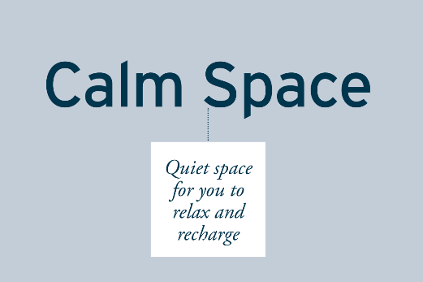  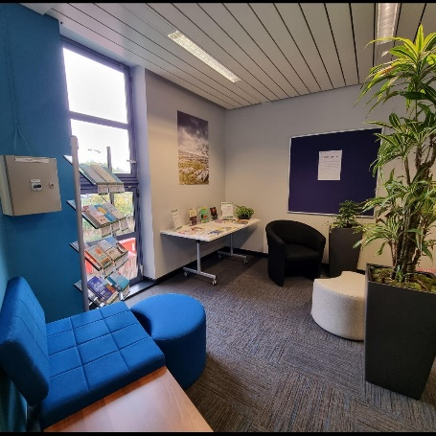  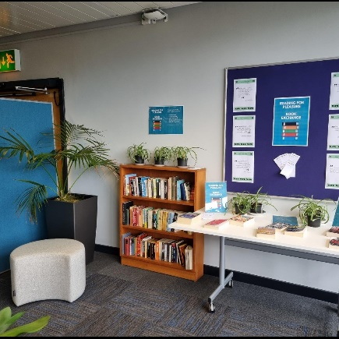  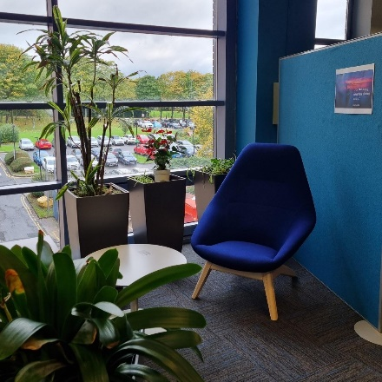
Resources  Is there a URL related to the initiative? | https://www.bradford.ac.uk/library/news/#d.en.83750 news item.
Your name, institution and contact details. Alison Lahlafi, a.lahlaf@bradford.ac.uk
Are you willing to share your contact details to other ALN staff so if they want to find out more they can contact you directly? Yes

