
Mental Health and Well-being Advocacy Resource: Template

Name of the initiative  Give a brief descriptive name for the activity or initiative you were involved in organising related to mental health and well-being | Common Thread  An opportunity for LBU staff to chat and share crochet, embroidery, knitting, mending and any other creative projects that we're working on. We can discuss our projects, share tips, help each other solve problems and foster a community of makers. Who knows?! This could be the start of the Great Beckett Sewing Bee!
Target group  Was it aimed at all students or staff or a particular group? | Initially aimed at staff in one Service (the Library), and 2 Schools (Art and Sport) as part of the Mentally Healthy Universities (MHU) programme. Now opened up to all staff at LBU.
Description  Give a short description of what was involved in organizing the activity or initiative. | Choosing a date during Time to Talk week and creating a 1 hourLesly meeting in MS Teams, then advertising to staff via bulletins, emails etc. I took the responsibility to arrange further 30 minute sessions (1 per month).
Partners  Was this solely run by the library or were other stakeholders involved, and if so how? Were students involved in planning the session, if so, how? | I organised this with a colleague from the School of Arts, supported by Leeds MIND during the MHU programme.
Strategy  How, if at all, was the activity linked into wider library or institutional strategy? | Linked to the Mentally Healthy Universities programme we were involved in for 12 months.
Evaluation  How, if at all, was the activity evaluated? | Anecdotal feedback gathered following each session. Emailed attendees for a more ‘formal’ approach.
What worked  Colleagues are looking for tips to help them run their events more effectively, what tips would you share to someone wanting to repeat what you have done?  If applicable, please include how many people attended (if an event) or engaged (e.g. website clicks) or another appropriate measure for your initiative. Did this match expected engagement? | Launching the first session to coincide with a mental health event worked well. Due to Covid, the sessions have only ever been online, but there is demand for on campus/physical sessions.  Having a theme in advance of the meeting (Christmas, Mental Health Week etc)  Not only posting the event on Teams, but also emailing those who have expressed an interest/who are regular directly, and asking them to forward to anyone who might be interested.
What did not work
What you would change if you were doing it again? Sharing what did not work can be as useful to help others as what did work.
Photo  Are there any photos you can share that give us a feel for the initiative? | 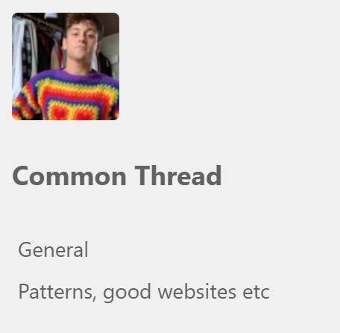
Resources
Is there a URL related to the initiative?
Your name, institution and contact details. Jo Horsfall, Leeds Beckett University j.horsfall@leedsbeckett.ac.uk
Are you willing to share your contact details to other ALN staff so if they want to find out more they can contact you directly? Yes

