
Mental Health and Well-being Advocacy Resource: Template

Name of the initiative  Give a brief descriptive name for the activity or initiative you were involved in organising related to mental health and well-being | eLearning content – Dealing with change: wellbeing for life
Target group  Was it aimed at all students or staff or a particular group? | Aimed at students but staff have also found it valuable.
Description  Give a short description of what was involved in organizing the activity or initiative. | In Dealing with change: wellbeing for life students learn about the importance of balancing their physical, mental, spiritual and emotional health and develop strategies to help them balance their wellbeing at key transition stages.  This content is available under Creative Commons BY-NC-SA.
Partners  Was this solely run by the library or were other stakeholders involved, and if so how? Were students involved in planning the session, if so, how? | The content was developed by Academic Support staff in collaboration with the University’s Counselling and Wellbeing team.
Strategy  How, if at all, was the activity linked into wider library or institutional strategy? | This content is linked to the Library’s commitment to supporting and promoting the wellbeing of colleagues and students. It is also part of the University’s strategic Enhancing Student Success work.
Evaluation  How, if at all, was the activity evaluated? | Students are invited to complete an evaluation form at the end of the content.  97 students have completed the evaluation. 90% say they will approach their studies as a result of completing the eLearning and
What worked  Colleagues are looking for tips to help them run their events more effectively, what tips would you share to someone wanting to repeat what you have done?  If applicable, please include how many people attended (if an event) or engaged (e.g. website clicks) or another appropriate measure for your initiative. Did this match expected engagement? | What worked well with this resource was creating content with the University’s wellbeing and counselling team. They inputted their professional expertise into shaping the content and supported library staff to create a resource with an appropriate, safe level of information for mental health self-help. The eLearning was designed as a first stop for students to discover self-help for their wellbeing and signpost professional services for students who require further support.
What did not work  What you would change if you were doing it again? Sharing what did not work can be as useful to help others as what did work. | As with all ‘pull’ learning opportunities the challenge is getting it in front of the right students at the right time – they won’t necessarily seek it out. Ensuring that the teams offering wellbeing support know about the resource and connecting it with key stages of the student journey would help to increase usage.
Photo  Are there any photos you can share that give us a feel for the initiative? | 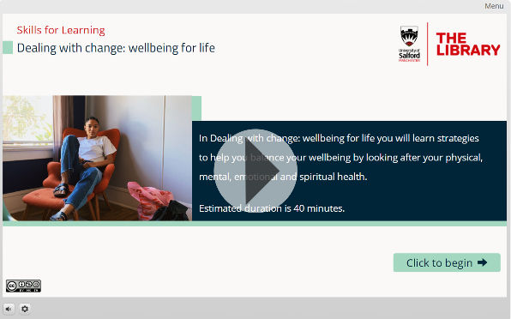
Resources  Is there a URL related to the initiative? | http://library-files.salford.ac.uk/elearning/uniskills/living-well/story.html
Your name, institution and contact details.
Amy Pearson/Nicola Sales
University of Salford
a.pearson@salford.ac.uk
n.sales@salford.ac.uk

Are you willing to share your contact details to other ALN staff so if they want to find out more they can contact you directly?
Yes

