
Mental Health and Well-being Advocacy Resource: Template

Name of the initiative  Give a brief descriptive name for the activity or initiative you were involved in organising related to mental health and well-being | LivLibPod – Podcast created by University of Liverpool Libraries own Wellbeing Team that focuses on student life and mental wellbeing.
Target group  Was it aimed at all students or staff or a particular group? | The project is aimed at students who miss our signposted wellbeing resources. Students are constantly on the go and traditional forms of media are mostly superseded by digital forms of ‘new media’, especially considering the demographic of our target audience which is young adults between 18-24. Staff are also invited to listen to the podcast and make contributions as a means to converge all university wellbeing services.
Description  Give a short description of what was involved in organizing the activity or initiative. | Firstly, I had to create and present a proposal that ensured the wellbeing team that the idea had purpose and would yield results. I looked at how other universities had created audio content for the purpose of supporting well-being. I also attended a seminar from a department within our own university call CIE (Centre of Innovation within Education) that outlined how to create a podcast using university resources. Once, all of the information was collated I worked with the Marketing and Communications team to outline the plan for the content of the episode and create any other visual materials to accompany the podcast.
Partners  Was this solely run by the library or were other stakeholders involved, and if so how? Were students involved in planning the session, if so, how? | There were many departments within the library who have contributed to creation of the podcast. These include the wellbeing working group, Marketing and Communication and Systems Support in the creation of the webpage.  As the project continues other internal stakeholders from outside the library have been involved and contributed to content as a means to signpost their resources. For example, we have worked to promote the residency artists of our universities own Victoria Museum and Gallery. We have also worked with Student Services to promote their services for international students over the Christmas break.
Strategy  How, if at all, was the activity linked into wider library or institutional strategy? | This links to the wider strategy of the Wellbeing Team. We want to be able to support student’s wellbeing by both signposting students to services that are available to them throughout the campus. We also want to support student wellbeing by making the library seem a comfortable and welcoming. To communicate with our current student’s, we want to use contemporary communications practices to promote positive wellbeing messages to students on the largest scale possible.
Evaluation  How, if at all, was the activity evaluated? | The activity is evaluated in several ways. Firstly, the activity is evaluated based on the amount of engagement from students. This is measured using the dashboard interfaces for Anchor FM and Google Analytics (via Podcasts). Secondly, the activity is evaluated in our wellbeing group meetings based on how we want to use the resource to communicate our current initiatives, effectively.
What worked  Colleagues are looking for tips to help them run their events more effectively, what tips would you share to someone wanting to repeat what you have done?  If applicable, please include how many people attended (if an event) or engaged (e.g. website clicks) or another appropriate measure for your initiative. Did this match expected engagement? | It is too early to tell. We have only released one episode and while the second one is ready to be released we have no form of comparison to see what worked better or worse in the second (in- difference to the first).
What did not work  What you would change if you were doing it again? Sharing what did not work can be as useful to help others as what did work. | It is too early to tell. We have only released one episode and while the second one is ready to be released we have no form of comparison to see what worked better or worse in the second (in- difference to the first).
Photo  Are there any photos you can share that give us a feel for the initiative? | 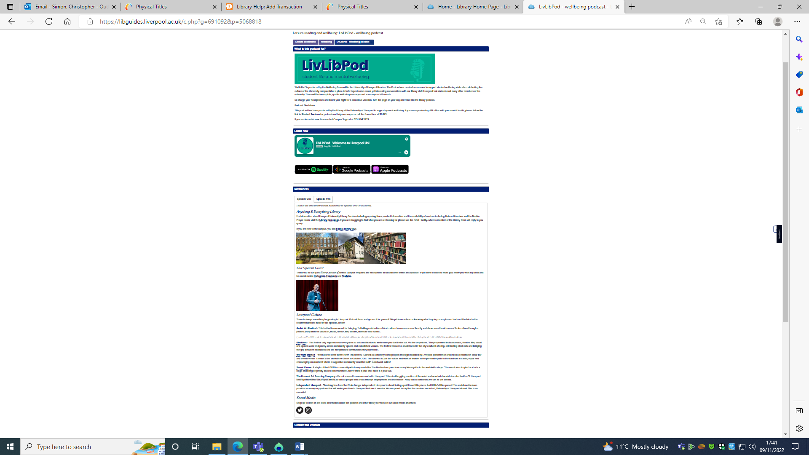
Resources  Is there a URL related to the initiative? | LivLibPod - wellbeing podcast - Leisure reading and wellbeing - Library at University of Liverpool
Your name, institution and contact details – University of Liverpool – C.T.Simon@liverpool.ac.uk
Are you willing to share your contact details to other ALN staff so if they want to find out more they can contact you directly? Yes.

