
Mental Health and Well-being Advocacy Resource: Template

Name of the initiative  Give a brief descriptive name for the activity or initiative you were involved in organising related to mental health and well-being | Big Thinking Trail to promote Staff and Student Health and Wellbeing on the University Campus
Target group  Was it aimed at all students or staff or a particular group? | University Staff , Students and Members of the General Public
Description  Give a short description of what was involved in organizing the activity or initiative. | Involved in organising a Big Thinking Trail on Campus in Peel Park to highlight the views of University Staff through recordings to talk about subjects on Health and Wellbeing , Inclusivity, Environment , Agile Working etc. The work involved commenting on how selected Staff envisaged this to look like in the future.  I did a short recording on how I envisaged Health and Wellbeing to look like in the future.
Partners  Was this solely run by the library or were other stakeholders involved, and if so how? Were students involved in planning the session, if so, how? | This project was run University Wide across Different Teams Departments in The University. 8 members of University Staff volunteered to choose a subject to do a short recording on. The idea being that for a short 2 week period , 19th April – 2nd May these recordings could be listened to on smart phones and mobile devices by scanning QR Codes while Staff and Students and members of the public were walking round Peel Park.
Strategy  How, if at all, was the activity linked into wider library or institutional strategy? | It was aligned to University Strategy on promoting Student Health and Wellbeing on Campus
Evaluation  How, if at all, was the activity evaluated? | The activity will be evaluated by questionnaires and feedback from those listening to the recordings when walking round Peel Park on the Big Thinking Trail
What worked  Colleagues are looking for tips to help them run their events more effectively, what tips would you share to someone wanting to repeat what you have done?  If applicable, please include how many people attended (if an event) or engaged (e.g. website clicks) or another appropriate measure for your initiative. Did this match expected engagement? | It was really good to set up an initial Meeting on Teams to discuss our collective goals for this venture and what we wanted to achieve from this. We all set up a virtual Chat on Teams where those involved in organising the Big Thinking Trail could contribute and share ideas and experiences.  Event is still going on so unable to give this information/data at present.
What did not work  What you would change if you were doing it again? Sharing what did not work can be as useful to help others as what did work. | I think with hindsight we could have involved and included some students with this initiative to make this more inclusive for greater representation of all groups and also I think in the future we need to consider those who might not want to engage as much with the digital technology , so that it isn’t the only way to listen to the recordings in the Park on smart phones.
Photo  Are there any photos you can share that give us a feel for the initiative? | 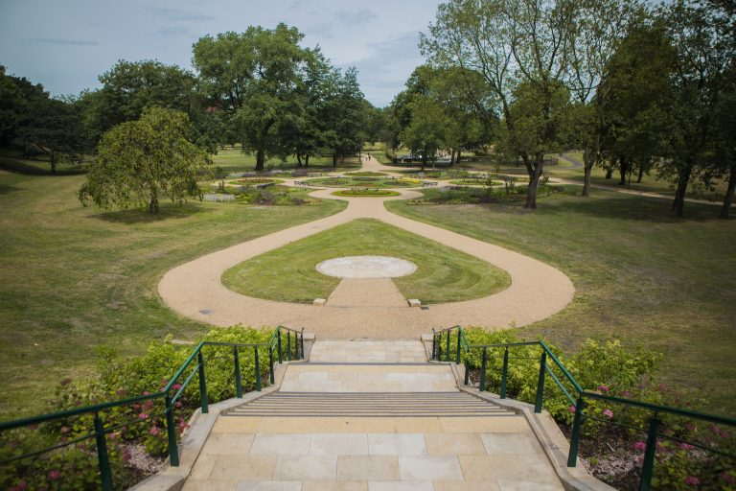
 | 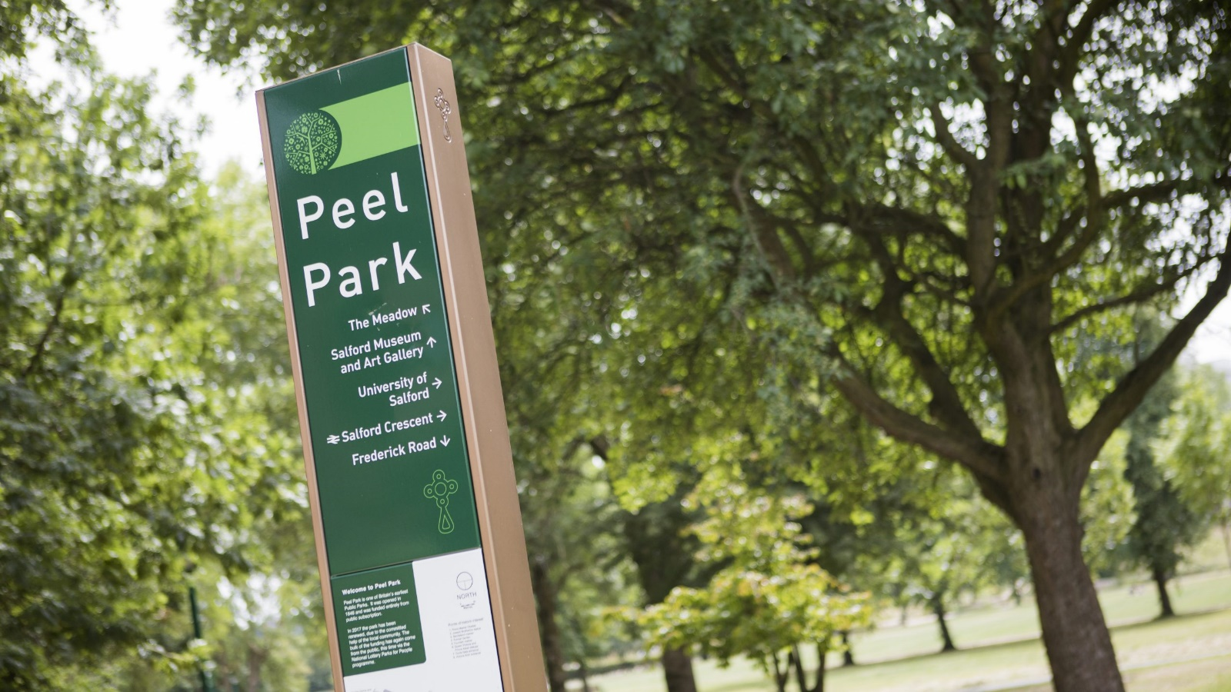
Resources  Is there a URL related to the initiative? | https://blogs.salford.ac.uk/environmental-sustainability/2022/04/19/salford-big-thinking-trail/
Your name, institution and contact details. Phil Jayes , The Library , Collections Team , Salford University (P.B.JAYES@SALFORD.AC.UK)
Are you willing to share your contact details to other ALN staff so if they want to find out more they can contact you directly? Yes

